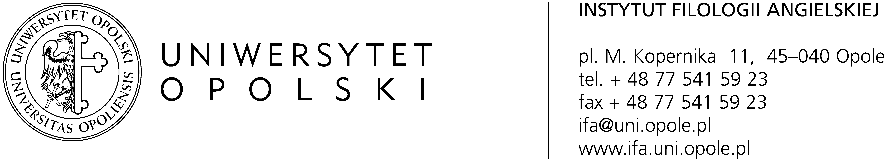

DECAY, DISEASE, DEATH in Literatures, Cultures, and Languages
University of Opole, 26-28 September 2016

Conference fee
Standard conference fee is 450 PLN or € 110
It includes all conference proceedings, daytime refreshments and gala dinner.
Postgraduate and doctoral students are eligible for a reduced fee of 350 PLN or € 75
Accommodation is not included in the conference fee and must be arranged separately.

Payment deadline for the conference fee is 15 July 2016.
Payment in Polish currency (PLN)
Bank Zachodni WBK S.A. 1 Oddz. w Opolu
09 1090 2138 0000 0005 5600 0043
Beneficiary: Uniwersytet Opolski, Pl. Kopernika 11, 45-040 Opole
Title of the payment: 3D Conference + your name

Payment in Euro
Account details:
PL88 1090 2138 0000 0005 5600 0076 (paid in EURO)
Beneficiary: Opole University, Pl. Kopernika 11, 45-040 Opole, Poland
Bank data: Bank Zachodni WBK S.A. 1 Oddz. w Opolu
SWIFT: WBK PP LPP
Title of the payment: 3D Conference + your name

Venue
The conference venue is the Institute of English of Opole University
Address: Collegium Maius, pl. Kopernika 11a, Opole

Accommodation
The conference fee does not cover accommodation, which must be arranged separately. As organisers, we recommend lodging in the following hotels:

- Hotel Kamienica (***, closest to the venue, approx. 100 m., 160 PLN per night)
- Hotel “Szara Willa” (***, approx. 400 m. from the venue, 199 PLN per night)
- Hotel Piast (***, from 300 PLN per night)
- Hotel Zacisze (**, from 110 PLN per night)

Exchange rate 1 EUR = 4.2 - 4.4 PLN

Our university offers budget accommodation in student lodgings in the Oleska Campus within a walking distance from the conference venue. The cost per night is 38 PLN (approx. 8 Euro). Payment for the rooms can be made upon arrival. If you are interested in this option, please let us know and specify the number of nights and exact dates.

Travel
The conference venue is easy to reach from the Opole Główne Railway Station and from the Opole Coach Station. Walk along ul. Kołłątaja or ul. Reymonta to reach pl. Kopernika. Collegium Maius is located near the Solaris shopping centre.

There is a large car park opposite Collegium Maius (payable between 8 am and 5 pm, follow instructions displayed on the meters)

Organizational details
The conference programme and the book of abstracts will be available at the beginning of September. Please follow our website http://culture.uni.opole.pl/ for more information.

In the programme, each speaker will be allocated 20 minutes for the presentation and 10 minutes for discussion. If you have a (multimedia) presentation, please arrive earlier to upload it to the computer in the assigned room.

To help us provide accurate information about your academic interests and achievements in the conference materials, please fill in the attached registration form.

If you need an official signed document confirming that your abstract has been accepted, please contact us via email.

If you have any further questions concerning the conference, please do not hesitate to contact us at deathdecaydiseaseconference@gmail.com.

